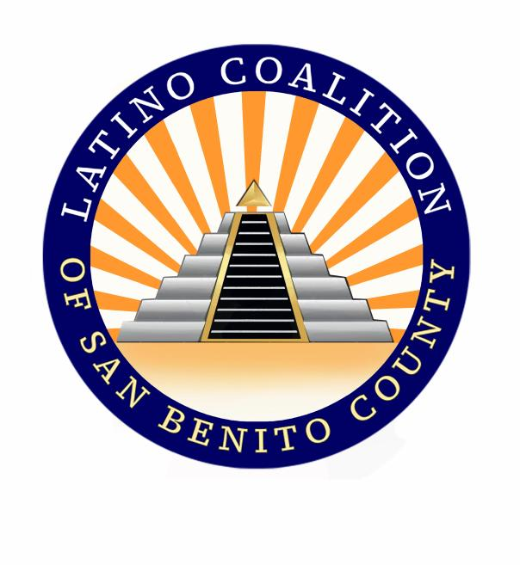
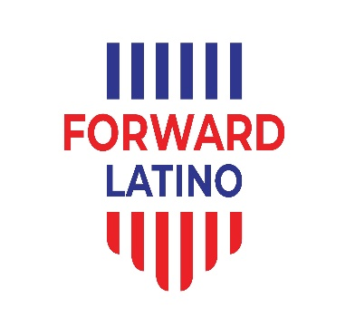

LATINO COALITION OF SAN BENITO COUNTY
Toll Free Information/Referral Line
1-877-550-4198

About the Latino Coalition of San Benito County:
Formed in 1988 by a group of Latino Leaders, The Latino Coalition of San Benito County is a group of local community members who are the cornerstone for positive change and representation of our culture. We share a common vision to create a unified platform that will empower the Latino community through advocacy, education and collaboration. https://latinocoalitionofsanbenitocounty.co/

About Forward Latino:
Forward Latino is a non-profit, non-partisan organization that empowers affiliates to inspire and engage communities, strengthen our democracy, improve the lives of working families, protect the environment, and stand up for equality and civil rights. Forward Latino cultivates, trains, and supports a diverse national network of Latina/o/x community leaders addressing the civic, economic, and political challenges of the 21st century. Forward Latino has members and affiliates across 29 states. www.forwardlatino.org

